Combined Workbook: R Lectures
Deadlines:
30OCT2025 – R Coursework
13NOV2025 – Python Coursework
Table of Contents
RK Royal Klube Mechanical Wireless Keyboard Shortcuts (US Version) [R compatioble] 3
General RStudio Shortcuts 3
R Markdown Shortcuts 3
Basics 4
Objects & Structure 4
Maths 4
Data Inspection 4
Indexing & Subsetting 4
Apply Family 4
Data Frames 4
Import / Export 4
Utilities 4
Key Concepts 2
Worked Coding Examples 2
Variable 2
Vector 2
Factor 2
Factor->Levels 2
Matrix 2
Dataframe 2
Key Concepts 3
Worked Coding Examples 3
Subsetting - Selecting 3
Add new column 1
Tidyverse - mutate other columns to add new column 1
Regular Expressions (Regex) in R (Searching/matching patterns) 1
String manipulation functions: 1
Example — grep (search; return row numbers) 1
Example — grepl (search; return TRUE/FALSE per element) 1
Example — gsub (replace ALL matches) 2
Example — sub (replace FIRST match only) 2
Anchors 2
Wildcards 2
Alternation (OR) 2
Escaping Special Characters 2
Perl-Compatible Regex 3
grep / grepl / gsub / sub 3
Anchors & Wildcards 3
How to write a regular expression 3
Regex Practice Exercises 4
Extract sample numbers 4
Find RNA-seq files 4
Extract treatment type 4
Extract timepoints 4
Identify BAM vs FASTQ 4
Installing files and manipulating data frames 5
B) Given data with no proper column (header) names 7
C) Given an Excel file (not txt, rmd or csv) 7
D) Given a RDS file (r data object) 8

R Programming Shortcuts

RK Royal Klube Mechanical Wireless Keyboard Shortcuts (US Version) [R compatioble]

Navigate & Select
Home / End — Start / end of line
Shift + Home / Shift + End — Select to start / end of line
Ctrl + → / Ctrl + ← — Jump by word
Ctrl + Shift + → / ← — Select by word
Ctrl + Home / Ctrl + End — Start / end of document

Edit & Format
Ctrl + D — Delete current line
Alt + ↑ / Alt + ↓ — Move line/selection up/down
Ctrl + Shift + C — Comment/Uncomment
Ctrl + Z / Ctrl + Y — Undo / Redo
Ctrl + X / Ctrl + C / Ctrl + V — Cut / Copy / Paste

Run Code (Scripts & Console)
Ctrl + Enter — Run line/selection
Ctrl + Shift + Enter — Run entire script/source

R Markdown (in .Rmd files)
Ctrl + Alt + N — Run current chunk
Ctrl + Alt + P — Run all chunks above
Ctrl + Alt + R — Run all chunks
Ctrl + Shift + K — Knit document

Search & Outline
Ctrl + F — Find
Ctrl + Shift + F — Find in files
Ctrl + Shift + O — Document outline (jump to sections/chunks)

Console
Ctrl + L — Clear console
Ctrl + ↑ / Ctrl + ↓ — Cycle command history

General RStudio Shortcuts
Ctrl/Cmd + Enter — Run current line/selection
Ctrl/Cmd + Shift + Enter — Run entire script
Ctrl/Cmd + Shift + M — Insert pipe %>%
Ctrl/Cmd + Shift + C — Comment/Uncomment line(s)
Ctrl/Cmd + D — Delete line
Ctrl/Cmd + L — Clear console
Ctrl + ↑ / Ctrl + ↓ — Browse console history
Ctrl/Cmd + f — Find
Ctrl/Cmd + Shift + F — Find in files

R Markdown Shortcuts
Alt + Ctrl + i / Option + Cmd + i — Insert R code chunk
Ctrl/Cmd + Alt + C — Run all chunks above
Ctrl/Cmd + Alt + R — Run all chunks in document
Ctrl/Cmd + Alt + n — Run current chunk
Ctrl/Cmd + Shift + K — Knit document
Ctrl/Cmd + Alt + i — Insert inline R code
Ctrl/Cmd + b — Bold text
Ctrl/Cmd + i — Italic text
Ctrl/Cmd + Shift + h — Insert section header

Common Built-In R Functions

Basics
c() → combine values into a vector
: → generate a sequence (1:10)
seq() → generate sequences with custom step (seq(1,10,2))
rep() → repeat values (rep(5, times=3))
<- NULL or [-3] → remove from object

Objects & Structure
length() → number of elements in a vector/list
dim() → dimensions (rows, cols) of matrix/data frame
nrow() / ncol() → number of rows/columns
names() → names of vector/list elements
colnames() / rownames() → names of matrix/data frame columns/rows
class() → the object’s class/type
str() → structure overview (super useful!)
typeof() / mode() → storage type of the object
( ) → put things inside functions, or group maths.
[ ] → pick rows, columns, or elements.
{ } → group a block of code (often in loops/functions).

Maths Functions
sum(), mean(), median(), sd() (standard deviation), var() (variance)
min(), max(), range()
round(), floor(), ceiling()
sqrt(), log(), exp()t.test(x,y) → compare two groups

Data Inspection
head() / tail() → first/last rows of data frame
View() (capital V in RStudio) → open spreadsheet-like viewer
summary() → descriptive summary of an object
table() → frequency table
unique() → unique values
which() → indices of TRUE values in a logical test

Indexing & Subsetting
[] → basic indexing
[[]] → extract contents from list
$ → access by name
subset() → filter data frames by condition

Apply Family
apply() → apply a function to rows/columns of matrix/data frame
lapply() → apply to each list element (returns list)
sapply() → apply to each list element (simplifies result)
tapply() → apply by groups (like group by)

Data Frames
data.frame() → create data frame
as.data.frame() → coerce into data frame
rbind() / cbind() → combine by rows/columns
merge() → merge two data frames by key

Import / Export
read.csv() / read.delim() → load data
write.csv() / write.table() → save data
saveRDS() / readRDS() → save/load single R objects

Utilities
help(functionName) or (functionName → help page
install.packages("pkg") → install package
library(pkg) → load package

Custom Function
myFun <- function(x){ return(x*2) }

Packages
install.packages("pkg") → install from CRAN
library(pkg) → load package
require(pkg) → load with warning if missing
BiocManager::install("pkg") → install from Bioconductor

Apply Functions
apply(X, 1, FUN) → apply FUN to rows
apply(X, 2, FUN) → apply FUN to columns
lapply(list, FUN) → apply to list, returns list
sapply(list, FUN) → apply to list, simplifies result

tidyverse
%>% → pipe operator (chain commands)
mutate(df, newcol = ...) → add/modify column
filter(df, condition) → subset rows
select(df, cols) → subset columns

ggplot2
ggplot(data, aes(x, y)) + geom_point() → scatter plot
ggplot(data, aes(x, y)) + geom_boxplot() → boxplot
aes() options: x, y, colour, fill, size, alpha
labs(x="..", y="..", title="..") → labels
theme() → customise appearance
facet_wrap(~var) → split plots by category

⚡ Tip: You don’t need to remember them all at once. The most used every day are:
c(), length(), names(), class(), str(),
head(), summary(),
[], $, [[ ]],
read.csv(), write.csv()

Lecture 1: Introduction to Programming

Key Concepts
Cues / Keywords | Notes
What is programming? | Giving the computer step-by-step instructions.
History | Babbage’s Analytical Engine; Ada Lovelace’s algorithm; evolution from machine code → R.
R language | Created in 1993, based on S. Open-source, built for statistics and data visualization.
Data types | Logical (TRUE/FALSE), Numeric, Integer, Character (text).
Data structures | Vector (1D same type), Matrix (2D same type), Dataframe (2D mixed), List (flexible).
Variable | Use <- or = to assign values.
Environment | Workspace in RStudio showing your objects, dataframes, and plots.

Worked Coding Examples

Variable
Storing values for BMI calculation
height <- 170
weight <- 65
bmi <- weight / (height/100)^2
bmi
Output:
[1] 22.49
👉 Variables let you reuse values (like height/weight) to calculate new things (BMI).

Vector
Storing ages of patients
ages <- c(34, 56, 45, 29, 61) or ages <- c(“30”, “twenty-two”, “5”)
ages[ages > 50]
Output:
[1] 56 61
👉 Vectors hold one type of data (numbers, characters, etc.). Here we filter patients > 50.

Factor
The levels — a higher-level overview of all the unique categories present.
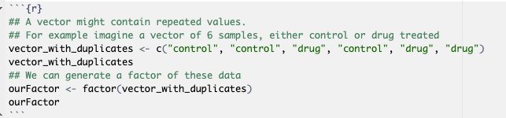
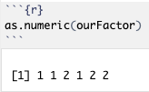
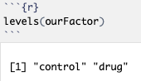
Vector = c("control", "control", "drug", "control", "drug", "drug" ). Factors convert this plain text to numbers which levels can then be pulled:
You can pull out just the levels like this
Check what R has assigned to control [1] and drug [2]

Factor->Levels
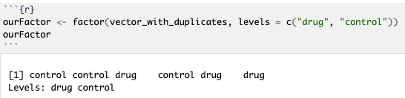
By default the levels will be assigned alphabetically, but you can specify any order you want:
Now stores drug as [1] and control as [2]

Matrix
Gene expression counts across samples
expr_matrix <- matrix(c(5,2,8, 3,6,1, 7,4,9), nrow=3, byrow=TRUE)
rownames(expr_matrix) <- c('Gene1','Gene2','Gene3')
colnames(expr_matrix) <- c('SampleA','SampleB','SampleC')
expr_matrix
Output:
SampleA SampleB SampleC
Gene1 5 2 8
Gene2 3 6 1
Gene3 7 4 9
👉 Each row is a gene, each column a sample. Only numeric values allowed.

Dataframe
Patient clinical data
patients <- data.frame(ID=c('P1','P2','P3'), Age=c(45,62,30), Diagnosis=c('NSCLC','SCLC','NSCLC'), Smoker=c(TRUE,TRUE,FALSE))
patients
Output:
ID Age Diagnosis Smoker
1 P1 45 NSCLC TRUE
2 P2 62 SCLC TRUE
3 P3 30 NSCLC FALSE
👉 Dataframes allow mixed data: numbers, text, logical values. Perfect for clinical data.

Common Beginner Mistakes

⚠️ Using '=' instead of '<-'
✔️ Both work, but '<-' is standard style.
⚠️ Forgetting quotes for strings
✔️ Always wrap text in quotes, e.g., "NSCLC".
⚠️ Mixing types in vectors
✔️ All values will be coerced to the same type.

Lecture 2: Data Manipulation

Key Concepts
Cues / Keywords | Notes
Load data and packages (eg. tidyverse) in R | Raw data comes from: .csv, .tsv, (plain text), .xlsx (excel for Manual Checking), .RDS, .RData (R-native).
Manipulate | Raw data needs cleaning, filtering, combining before analysis
Data formats | DataFrame/Matrix/List/Variable
Subsetting | Selecting
Regex | Searching/matching patterns

Worked Coding Examples

Subsetting - Selecting

Vectors
You can subset (pick out) first three items of a vector, for example:
Vector_of_stringsvector_of_strings[c(1,2,3)]
vector_of_strings[1:3]

Factors
Works same way as subsetting vectors ; # first two items
ourFactor[1:2]
as.numeric(ourFactor[1:2]) # use numerical versions
👉 When you subset a factor, it keeps all original levels, even if some don’t appear in the subset.
Use droplevels() to remove unused levels after subsetting our dataframe:
(droplevels(ourFactor[1:2]))

Dataframes
Use subset() function to retrieve column and row names: colnames(iris) # names of columns rownames(iris) # names of rows
Mixed data types

Numbered rows and columns:
iris[1:10,] rows only # Output -> 10 rows of data
iris[,1:2] columns only # Output -> 2 column of data
iris[1:10,1:2] rows, columns # Output -> first 2 columns containing 10 rows of data
Numbers and Strings combined:
iris[c(10, 15, 17, 18), c("Sepal.Width", "Species")] #>1 row and column
String rows and columns:
iris[,c("Sepal.Length")] # return just one named column iris[,c("Sepal.Length","Sepal.Width")] # return multiple columns
A subset of a population (use subset condition):
subset(dataframe, row name, column name)
subset(iris, Species == "setosa", select = Sepal.Length)
Output:
ID Age Diagnosis Smoker
2 P2 62 SCLC TRUE

Lists
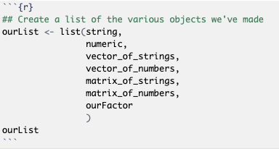
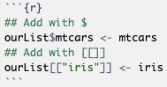
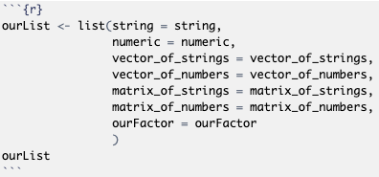
Mixed data types.
Purpose: For bundling all objects you’ve made together instead of having to remember each individual part;
Data manipulation: You can add elements to the list or extract individual elements of a list using [[ ]] or $ if named ; [["itemName"]] or $itemName
FYI: be careful not to donate a name that is already commonly used as a function etc in R as it will cause errors and clashes later on, eg use num instead of numeric and vec instead of vector.
rose
ferrari
- Identify list (ourList)
- $mtcars or [[“mtcars”]]– specifically overwirte ‘mtcars’ object in list/create new one if ‘mtcars’ doesn’t exist
- add object’s name = ferrari
List function

Add new column
Add BMI column
patients$BMI <- c(22.5, 28.1, 19.8)
head(patients)
Output:
ID Age Diagnosis Smoker BMI
1 P1 45 NSCLC TRUE 22.5
2 P2 62 SCLC TRUE 28.1
3 P3 30 NSCLC FALSE 19.8
👉 Dataframes can be extended with new columns, e.g., calculated measures like BMI.

Tidyverse - mutate other columns to add new column
Adding risk classification
library(dplyr)
patients <- patients %>% mutate(Risk = ifelse(Age>50,'High','Low'))
patients
Output:
ID Age Diagnosis Smoker BMI Risk
1 P1 45 NSCLC TRUE 22.5 Low
2 P2 62 SCLC TRUE 28.1 High
3 P3 30 NSCLC FALSE 19.8 Low
👉 Mutate adds new columns cleanly using conditions.

Regular Expressions (Regex) in R (Searching/matching patterns)
Regular expressions are text-matching patterns. They are essential for extracting information from filenames, sample IDs, or metadata.

String manipulation functions:

Example — grep (search; return row numbers not literal text)
Code: subset(grep('\\.bam$', files))
grep → search filenames; return the row numbers of matches (name comes from Unix g/re/p).
\\. → wildcard – a literal dot (.).
bam → the letters "bam".
$ → anchor for end of string.
files → vector of filenames being searched.
👉 Finds which files end with .bam and returns their positions.

Example — grepl (search; return TRUE/FALSE per element) will return literal text
Code: subset(grepl('^RNAseq', files))
grepl → like grep, but returns TRUE/FALSE for each filename.
^ → anchor for start of string.
RNAseq → literal text.( Return rows where grepl returns true)
files → vector of filenames being checked.
👉 Tells you whether each filename starts with “RNAseq”.

Example — gsub (replace ALL matches)
Code: subset(gsub('.*_(Drug|Control)_.*', '\\1', files))
gsub → global substitution (replace all matches).
.*_ → wildcard - any text up to an underscore.
(Drug|Control) → capture the word “Drug” or “Control”.
_.* →wildcard - another underscore and the rest of the text.gsub
\\1 → wildcard - replace with the first captured group.
files → filenames being processed.
👉 Extracts the treatment type (Drug or Control) from each filename.

Example — sub (replace FIRST match only)
Code: subset(sub('Sample', 'S', 'RNAseq_Sample12'))
sub → replace only the first match.
Sample → text to find.
S → replacement.
👉 Changes "RNAseq_Sample12" into "RNAseq_S12".

Anchors
grep('^RNAseq', files) # ^ = starts with
grep('bam$', files) # $ = ends with
[1] 1 2 # files starting with RNAseq
[1] 3 # file ending with bam
👉 Anchors match positions, not characters. ^ = beginning, $ = end.

Wildcards
^ start • $ end • . any char • \\. literal dot • [0-9] digit • [0-9]+ 1+ digits • (A|B) A or B • ( ) capture • ? 0/1 • * 0+ • + 1+ • {n} exactly n

Example:

files <- c(
'RNAseq_Sample1_Control_24h.fastq.gz',
'RNAseq_Sample12_Drug_72h.fastq.gz',
'ChIPseq_Sample3_Control_24h.bam',
'ATACseq_Sample4_Drug_48h.fastq.gz'
)

Pattern | Meaning | Example (R code) | Matches (per file)
. | Any single character | grepl('Sample.', files) | TRUE, TRUE, TRUE, TRUE
._ | One char + underscore | grepl('Sample._', files) | TRUE, FALSE, TRUE, TRUE
.* | Any sequence | grepl('Sample.*Drug', files) | FALSE, TRUE, FALSE, TRUE
[0-9] | One digit | grepl('Sample[0-9]', files) | TRUE, TRUE, TRUE, TRUE
[0-9]+ | One or more digits | grepl('Sample[0-9]+', files) | TRUE, TRUE, TRUE, TRUE
[0-9]{2} | Exactly two digits | grepl('Sample[0-9]{2}', files) | FALSE, TRUE, FALSE, FALSE
_? | Zero or one underscore | grepl('Sample[0-9]_?', files) | TRUE, FALSE, TRUE, TRUE
^ | Start of string | grepl('^RNAseq', files) | TRUE, TRUE, FALSE, FALSE
$ | End of string | grepl('bam$', files) | FALSE, FALSE, TRUE, FALSE

Alternation (OR)
gsub('.*_(Drug|Control)_.*', '\\1', files)
[1] 'Control' 'Drug' 'Control' 'Drug'
👉 `(Drug|Control)` matches either word.

Escaping Special Characters
grep('\\.bam$', files)
[1] 3
👉 Use `\\.` to match a literal dot, since `.` means any character.

Perl-Compatible Regex
gsub('.*Sample(\\d+).*','\\1', files, perl=TRUE)
[1] '1' '12' '3' '4'
👉 With `perl=TRUE`, you can use shortcuts: `\\d` (digit), `\\s` (space), `\\w` (word chars).

Regular Expression Summary
Purpose: pull out bits of information from text eg. Finding out whether patient 1 was drug or control group.

grep / grepl / gsub / sub
Function | Meaning | Typical use | Example
grep() | Returns indices of matches | Which entries match? | grep('SCLC', patients$Diagnosis) # 2
grepl() | TRUE/FALSE for each entry | Filter rows | patients[grepl('NSCLC', patients$Diagnosis), ]
gsub() | Replace all matches | Clean labels | gsub('NSCLC','Lung Cancer', patients$Diagnosis)
sub() | Replace first match only | Rename partial strings | sub('Sample','S','RNAseq_Sample12')

Anchors & Wildcards

^ = start • $ = end • . = any char • \\. = literal dot • [0-9] = one digit • [0-9]+ = one/more digits • ( ) = capture group • (A|B) = A or B • ? = zero/one • * = zero/more • + = one/more • {n} = exactly n

How to write a regular expression
Grep/grepl/gsub/sub ( location targeted with wildcards directing text within or ensuing , first / second / third of its kind , file selected from )
Common Beginner Mistakes

⚠️ Forgetting delimiter in read.delim
✔️ Use sep=',' for CSVs.
⚠️ Mismatched row/col names when merging
✔️ Always align colnames with rownames.
⚠️ Wrong dimensions in cbind/rbind
✔️ Check number of rows/columns match.
⚠️ Using mutate without tidyverse
✔️ Run library(tidyverse) first

Regex Practice Exercises
files <- c(
'RNAseq_Sample1_Control_24h.fastq.gz',
'RNAseq_Sample12_Drug_72h.fastq.gz',
'ChIPseq_Sample3_Control_24h.bam',
'ATACseq_Sample4_Drug_48h.fastq.gz'
)

Extract sample numbers
gsub('.*Sample([0-9]+).*','\\1', files)
[1] '1' '12' '3' '4'

Find RNA-seq files
grep('^RNAseq', files)
[1] 1 2

Extract treatment type
gsub('.*_(Drug|Control)_.*','\\1', files)
[1] 'Control' 'Drug' 'Control' 'Drug'

Extract timepoints
gsub('.*_([0-9]+h).*','\\1', files)
[1] '24h' '72h' '24h' '48h'

Identify BAM vs FASTQ
grep('\\.bam$', files)
grep('\\.fastq\\.gz$', files)
[1] 3
[1] 1 2 4

Installing files and manipulating data frames

Setting up – Save your external data and create an ‘Output’ folder to local downloads folder on Mac (where R is stored).

```{r} Install and load required packages -
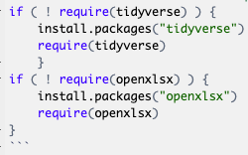

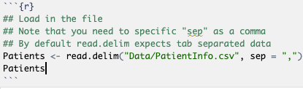
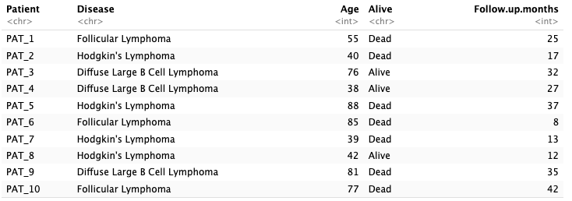
Load files: make sure you add sep “,” or “;” etc, depending on what separates columns if load csv file in rea.delim or just use read.csv("Data/PatientInfo.csv") -> will produce dataframe (different datatypes) -

Manipulate your loaded dataframes:

Setting row/column names (or assigning row/column names) when you import a dataset

patients <- read.csv("Data/PatientInfo.csv", row.names = 1)
- read.csv → “read a CSV file”
- "Data/PatientInfo.csv" → the file you want to read (inside a folder called Data)
- row.names = 1 → tells R: “Use the first column in the file (Patient IDs) as the row names (labels), not as normal data.”
- <- means “save it into”
- patients → the name we’re giving the data table in R.

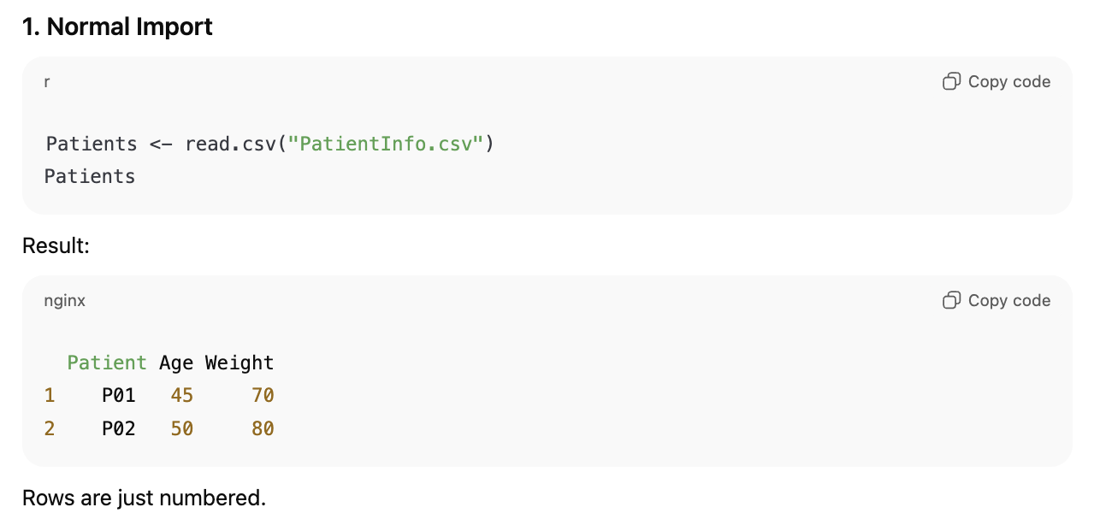
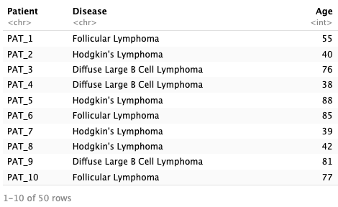

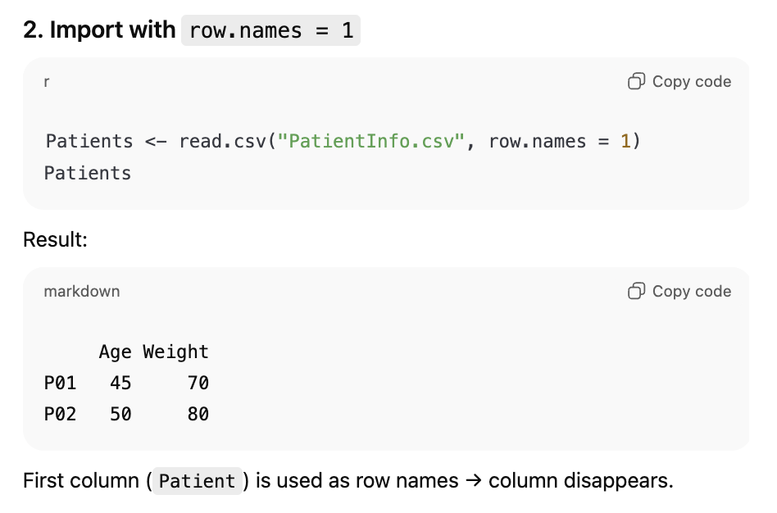
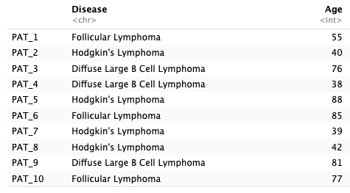

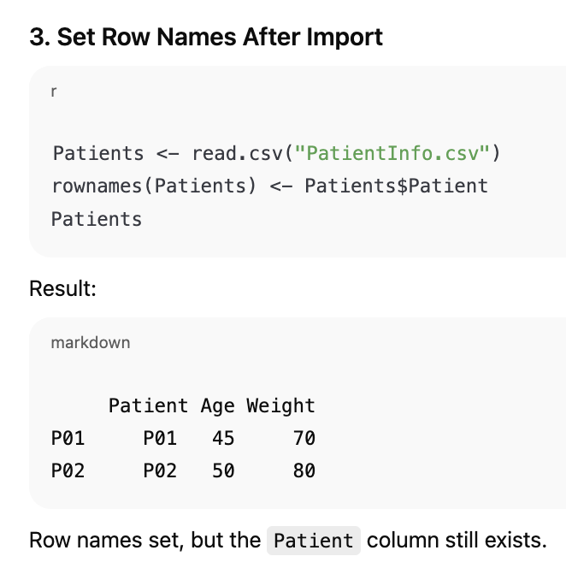
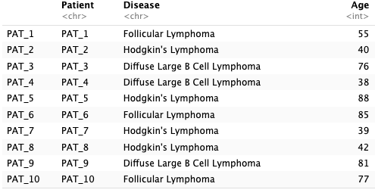

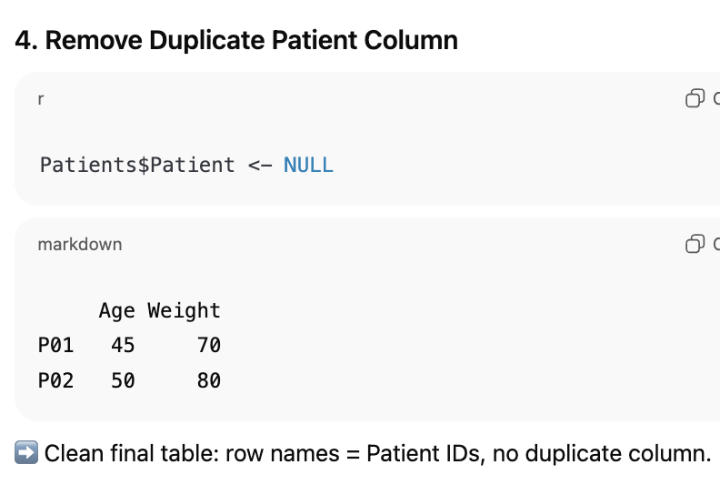
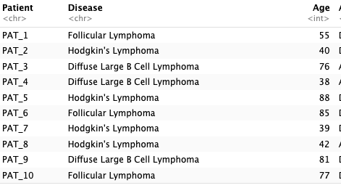

Given data with no proper column (header) names
read.delim("PatientInfo.csv", sep = ",", header = FALSE, skip = 1)
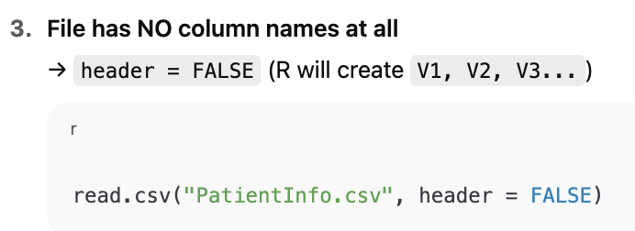
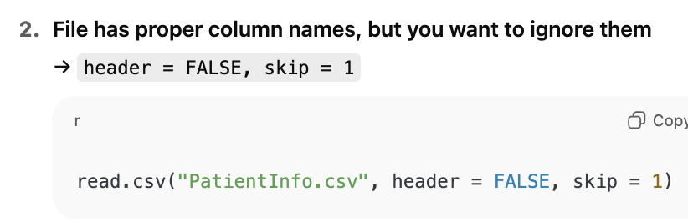
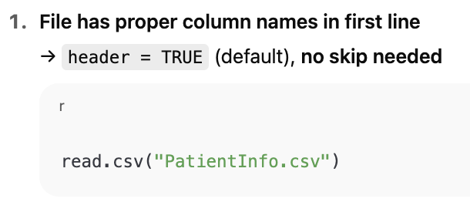

Given an Excel file (not txt, rmd or csv)
PatientsXLSX <- read.xlsx("Data/PatientInfo.xlsx", sheet = "Patients")) #read xlsx file and call on sheet 1 (patients) if data stored here
PatientsXLSX #call the file
Patients2XLSX <- read.xlsx("Data/PatientInfo.xlsx", sheet = "Patients2") #Patients2 is much bigger than Patients
Patients2XLSX

Start with read.xlsx().
If your file takes ages to load or R throws memory warnings → switch to read.xlsx2(). (for bigger packages)

Given a RDS file (r data object)
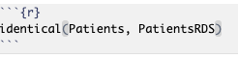
PatientsRDS <- readRDS("Data/Patients.rds")
Check the r data object matches the imported data from the csv file exactly

Save your loaded manipulated data files:
When you’ve finished your analysis, you’ll often want to save results. The format depends on what you (or your collaborators) will use next:
- Text files → .csv, .tsv, .txt (good for sharing, small, easy to open in Excel/Notepad).
- Spreadsheets → .xlsx, .ods (handy if collaborators want to open directly in Excel/LibreOffice).
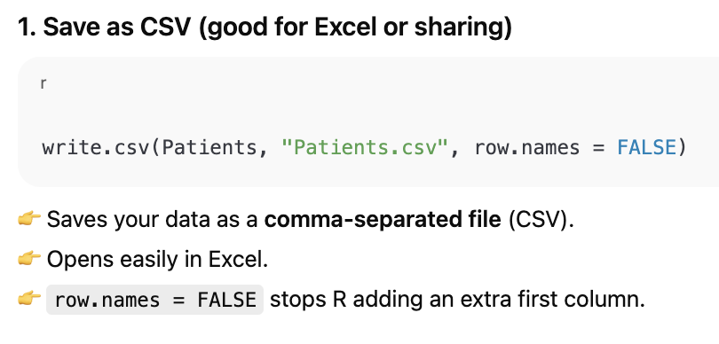
- R objects → .rds, .RData (best for your own work, because they preserve R-specific structures).
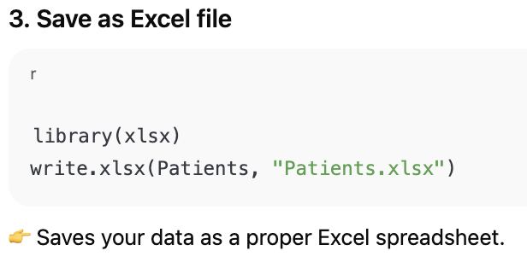
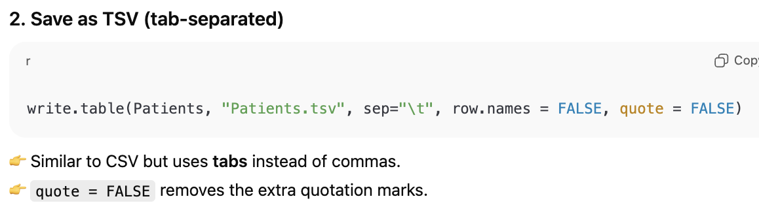

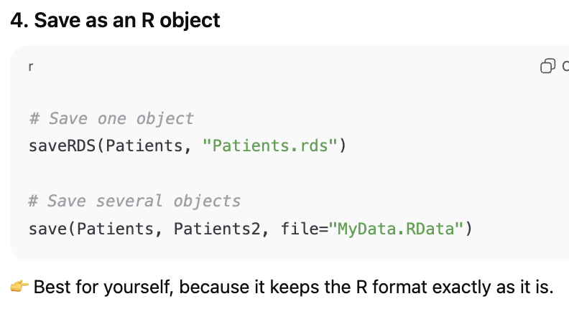

✅ Summary
- Use CSV/TSV if you’re sharing with others or want to open in Excel.
- Use Excel (.xlsx) if collaborators prefer spreadsheets.
- Use RDS/RData if you plan to load it back into R later.

Lecture 3: Functions, Modules, and Plotting with ggplot2

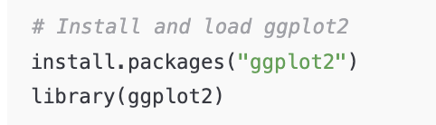
Packages and Modules
Example: Installing and loading ggplot2
Packages are like toolboxes in R. They contain pre-written functions that you can use.

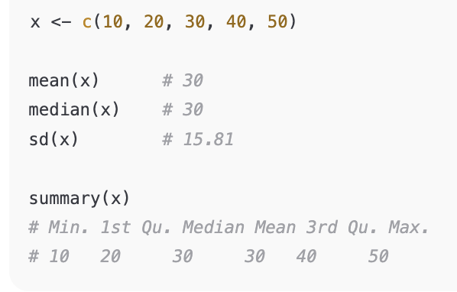
Statistics in R
Example: Basic statistics

Apply Functions & Loops
Sign denoting the start of a loop
Loops
A loop means to do the same thing again and again for each item in a list.
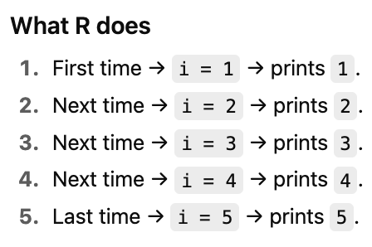
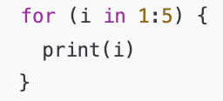
Start with 1, then 2, then 3, then 4, then 5
Print each item in the list one after another
Curly brackets groups the chunks that should be run together; in this example, the code will print all items at once

Apply
A loop for 2 dimensional matrices or tables that works across all rows or all columns of your table; it accounts for the dataframe, rows and columns, rather than simply a 1 dimensional vector or list.

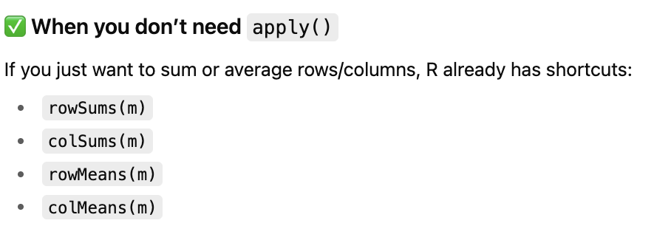

✅ When apply() is useful

Use the apply tool where there isn’t an already built in function for what you need for each row and column for example, finding the min and max of each or for your own self-made functions.
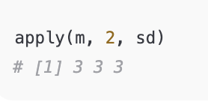
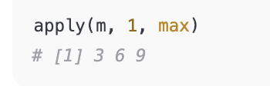

Tidyverse & Pipes
The tidyverse makes data manipulation easier and more readable using the pipe operator (%>%).
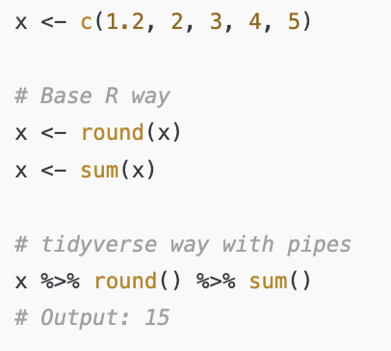
Example: Piping operations

ggplot2

What is ggplot2?
ggplot2 allows you to build plots step by step by layering components.
You give it your dataframe, tell it what goes on the x-axis and y-axis, and then add layers (like points, lines, or boxes).
Think of it like lego for plots – you stack pieces together.

The three main parts of a ggplot
- Data + mapping (aes) → which columns go on x and y.
- Geom (geometry) → what type of plot (scatter, boxplot, line, etc).
- Extras → labels, themes, split into panels.
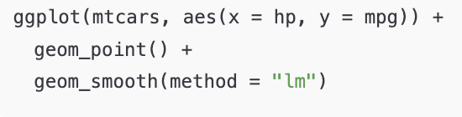
Cylinders on x axis, miles per gallon on y axis
Database
Makes a scatter plot
Treats cylinder numbers like it’s a group
Boxplots get different colours
Draws boxplots
👉 Scatter plot with a fitted line:

Add line of best fit
Example 1. Basic graph
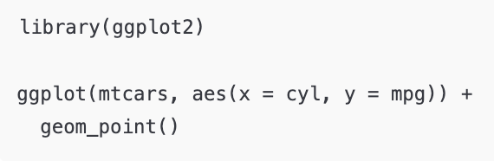

Example 2: Adding colour and fill

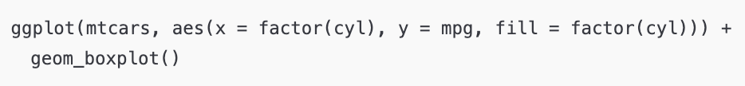
Types of geom_ … (graphs):
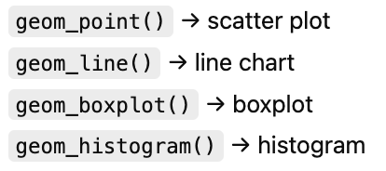

Example 3: Labels and Themes
Changes axis labels and title
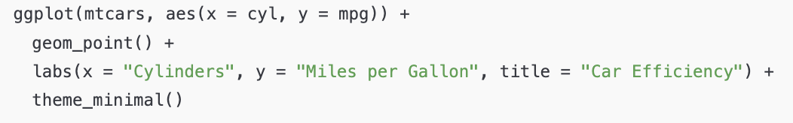
Theme = clean, simple style
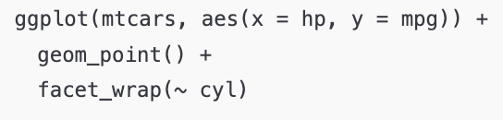
Example 4: Splitting Plots by Groups

Explaining facet_wrap:
Makes separate mini-plots for each cylinder group.

Without facet_wrap:
- One scatter plot with all the dots mixed together (4, 6, and 8 cylinders all shown with different colours).

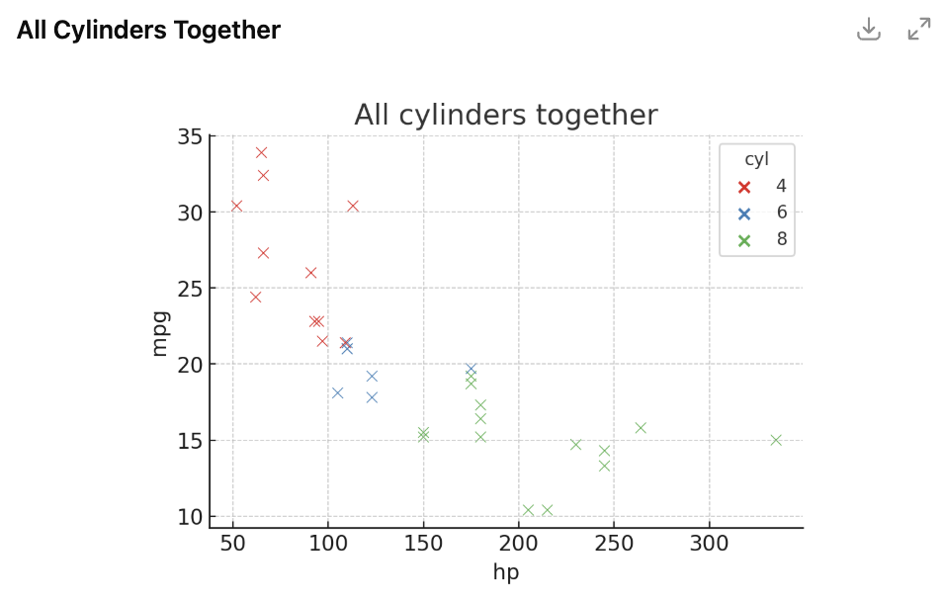

With facet_wrap:
- Three smaller scatter plots –
  - One shows only 4-cylinder cars
  - One shows only 6-cylinder cars
  - One shows only 8-cylinder cars

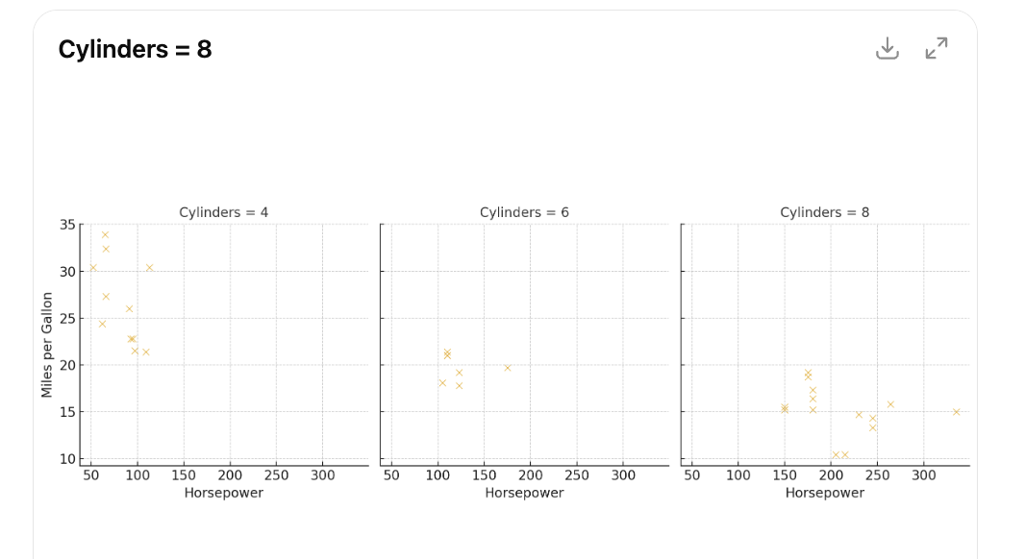

Lecture 4: Writing Functions and Classes

0) Packages (Biobase / maftools)
What’s a package? a bundle of functions + help docs + sometimes example data.
- Biobase gives you the ExpressionSet class (a tidy container for gene expression + metadata).
- maftools is for mutation (MAF) data: loading, summarising, and plotting.
Install vs load
- install.packages("pkg") (or BiocManager::install("pkg")) — do this once per machine/environment.
- library(pkg) — do this every time you start a new R session and want to use it.
Common install issues (Mac):
- If you see compilation errors, install Xcode Command Line Tools: open Terminal → xcode-select --install.
- For Bioconductor packages, always install BiocManager first, then BiocManager::install("Biobase").

Why Write Functions?
Most of the time, existing functions in R already exist and have been tested. But if you repeat the same task many times, it makes sense to write a function:
- Saves time
- Improves reproducibility
- Reduces errors
👉 Rule of thumb: if you’ve copied code more than twice, make it a function.
👉 Functions should do one clear job and have meaningful names.
Bad: Function4_secondtry_final
Good: RenameFileHeader

Functional vs Object-Oriented Programming

Functional programming ( R ):
- A function only affects its return value
- No side effects (don’t rely on outside variables)
Object-oriented programming (Python):
- Objects contain both values and functions
- Objects inherit from a blueprint (class)
- Used for specific data types/tasks

Step 1: Writing Functions
A function is a tiny machine: you give it inputs (arguments) → it does work → it returns exactly one output.

Functions: Vector Functions
Use a vector function when you’re given a vector and are plugging items/numbers from it into calculations.
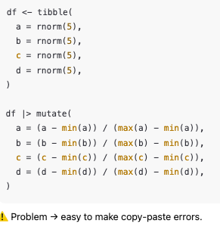
Turn it into a function
Example: Using a built-in function
Example: Writing your own function
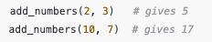
Now you can reuse it:
Name of your function
<- stores what comes after it under this name.
Function tells R: I’m making a function here.
(a, b) are inputs/arguments. When you call the function, you replace them with real values as seen below (see “Now you can reuse it”.)
The curly braces hold the code block that will run when the function is called.
Task of the input/arguments in the function. Ie. adds a + b together.
Returns the output of the sum back to you- not just run it and store inside function
‘Call’ the function: tell the function what you want to input. In future, call only this block; you no longer need to write the entire function out.

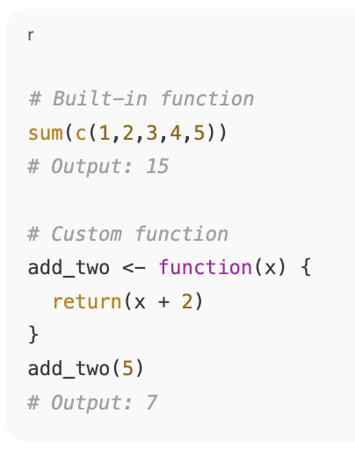
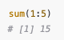
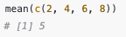
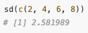
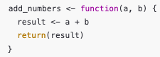

Functions: Logical (“If” minus the word “and” “or” “reminder” “even” etc in question

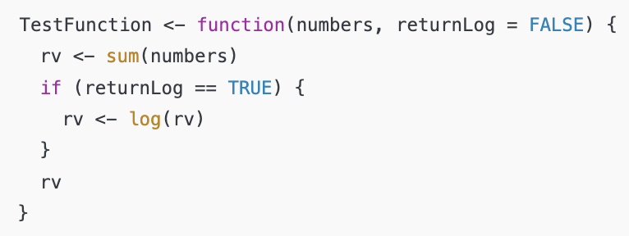
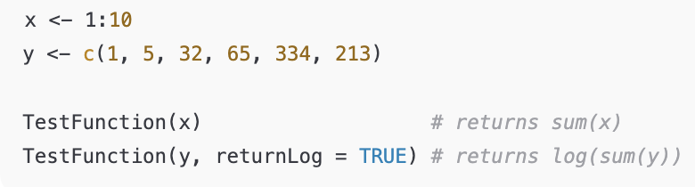
A
Name of function-
Pick clear names; avoid clashing with existing functions like mean, sum, vector, numeric, etc
Arguments-
Numbers; expected to be numeric (vector like c(1,2,3).
returnLog = FALSE -> default value (if you don’t pass it it’s FALSE).

Stores the sum in a variable named rv (“return value”)
Conditional formatting the function
Conditionally modifies rv. If returnLog is set to FALSE, the numbers are summed up (sum(numbers)) without converting them into a log value.

If returnLog is set to TRUE, the numbers are summed and a log value is created.
Store the return

The last evaluated object in the function is returned automatically (here rv).
Add parameters for numbers argument
Call function and its log form (if stored)

Functions: Operator Expressions ( %in%, %%, == , !=, >, <, >=, <=) “and” “or” “divisible” “remainder”
In all these cases, the expression already produces TRUE or FALSE, so you can return it directly inside a function without wrapping it in if, it will return TRUE/FALSE.
Check if a number is between 10-20 >= <=:
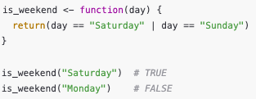
Check if it is a weekend (sat OR | sun):
Check if a number is divisible by 3 (%%):
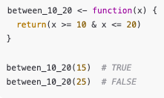
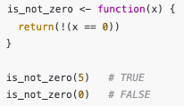
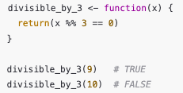
Check if a number is NOT zero (!==)
Using a set vector in input
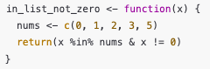
If you always want the same list, you can hard-code it into the function and it can be referred to in the task.

Common pitfalls
- Wrong types: sum() expects numbers; characters will coerce or error. Use is.numeric(numbers) to guard if needed.
- NA values: sum(c(1, NA)) returns NA. Use sum(numbers, na.rm = TRUE).
- Log of non-positive numbers: log(0) = -Inf, log(negative) = NaN. Guard with checks if needed.

Step 2: If / else (decision making)
Sometimes you want your code to make a decision. That’s what if does.
It’s like a fork in the road:
- If the condition is TRUE → go down this road.
- Otherwise → go down the other road.
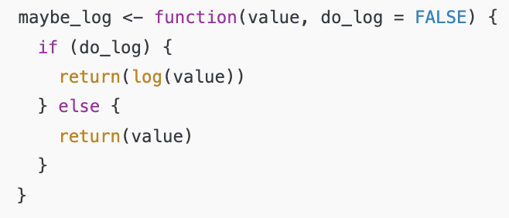
If do_log is TRUE, you get the log.
If not, you just get the original value.

Step 3: The ExpressionSet (a special container)
Imagine you’re doing an experiment. You have:
- A big spreadsheet of gene expression counts (rows = genes, columns = samples).
- A table of sample information (like patient ID, treatment, batch).
- A table of gene information (like which chromosome each gene is on).
If you keep them as three separate files, you can easily mess up (delete a sample in one but not the others).
👉 ExpressionSet glues them all together, so when you filter or reorder, everything stays aligned.

Build it step by step
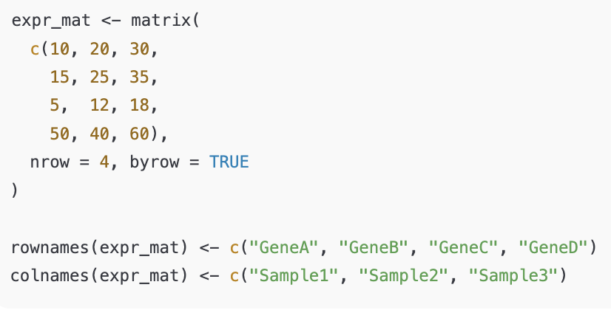
1) Expression matrix (the main numbers)

👉 Rows are genes, columns are samples.
We give them names so R knows who’s who.

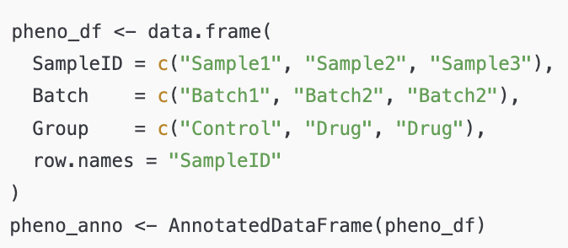
2) Sample info (who are the patients/samples?)

👉 On the sample info table (separate to expression matrix table), each row = one sample. We add info like batch and treatment group.

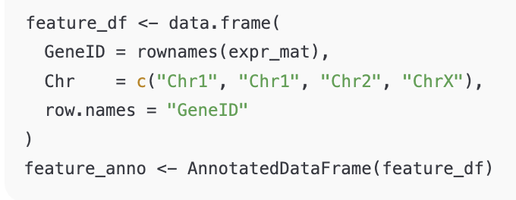
3) Gene info (extra labels for the genes)

👉 On the gene info table (again, a separate table to the two above), each row = one gene. We add info like which chromosome it belongs to.

4) Put them all together
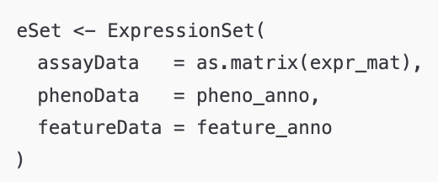
Now eSet is like a smart folder holding everything neatly linked.

How to look inside
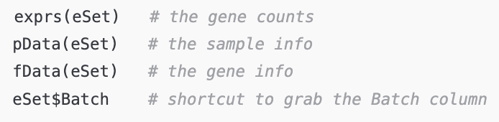

Subsetting (accessing info) safely
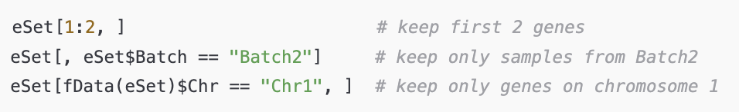

Step 4: Z-scores (normalising)
Sometimes genes have very different ranges.
One gene might be always ~1000, another always ~5. Hard to compare!
👉 A z-score rescales so each gene has mean 0 and SD 1.
  - apply(..., 1, zscore) = apply zscore row by row (gene by gene).
  - t() flips it back to the right shape.
  - We overwrite exprs(eSet) so now the expression values are standardised.

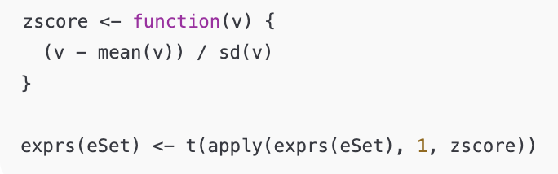

Step 5: maftools (mutation data)
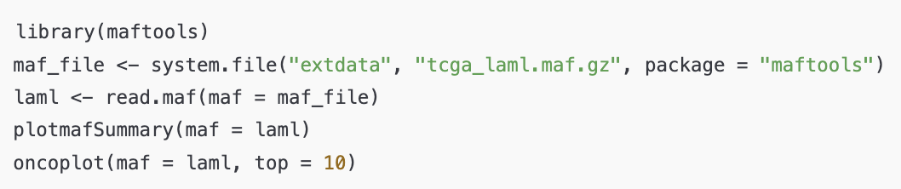
This package is for mutation data (files in MAF format).
It can:
- Load mutation calls from a cancer cohort.
- Summarise mutation types and frequencies.
- Plot nice figures (like oncoplots: top mutated genes per patient).

